UAV-Drone Operation Training for Gyalsung Instructors
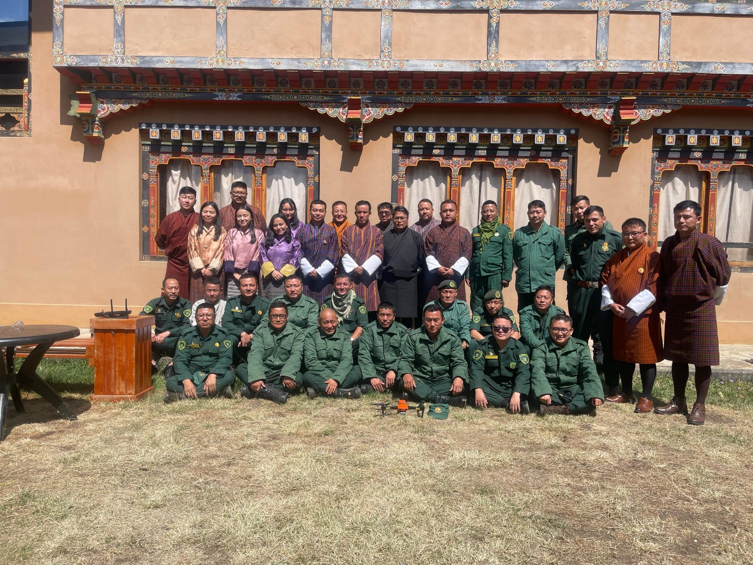

The Bhutan Ecological Society in collaboration with the Nature Conservation Division, Department of Forests and Park Services is organizing a five-day UAV-Drone Operation training program for Gyalsung instructors from 21st to 25th April 2025 at Lhayul Hotel, Haa. 37 officials from the various field offices under the Department of Forests and Park Services (DoFPS) and the Bhutan Ecological Society (BES) are participating in the training. The training is led by resource personnel from the Forest Monitoring and Information Division, DoFPS
The objectives of the training are to:
- Build capacity in drone operation, mission planning, and post-processing techniques
- Promote adherence to UAV regulations and safety standards
- Conduct hands-on assessments to evaluate participants' proficiency in drone handling
The training program is part of the project “ Fostering Harmony: Integrating Human-Wildlife Coexistence into the Gyalsung Program” funded by the World Bank.

