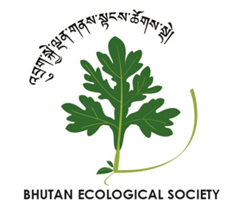
Booth Reservation Form

BES Fifth Annual Environmental Fair & Research Symposium

Contact Information
Name: | Click here to enter text.
Company/  Organization: | Click here to enter text.
Phone Number: | Click here to enter text.
Email Address: | Click here to enter text.

Booth Description
Booths will be 3-sided covered enclosures, approximately 8 feet wide × 8 feet deep. BES is unable to provide amenities such as tables, chairs, or electrical supply for exhibition booths.
Type of booth:
☐ Educational Product Booths sell wildlife and nature-related books, CDs, videos, reference posters, and other conservation education materials.
☐ Information Booths primarily display information on conservation issues, projects, and activities in Bhutan. They may also sell local products relevant to their display.

Describe the products or information you will be displaying:

Other Information

How did you hear about this event?

Any questions, comments, or requests?
Click here to enter text.

Completed forms should be emailed to contact@beso.org.bt by Saturday, 20 October 2018. The booth reservation is not final until you receive a confirmation email from the Symposium Organizing Committee.

For more information, please call us at 02 330346/17554910.

